**Bug report & error summary**

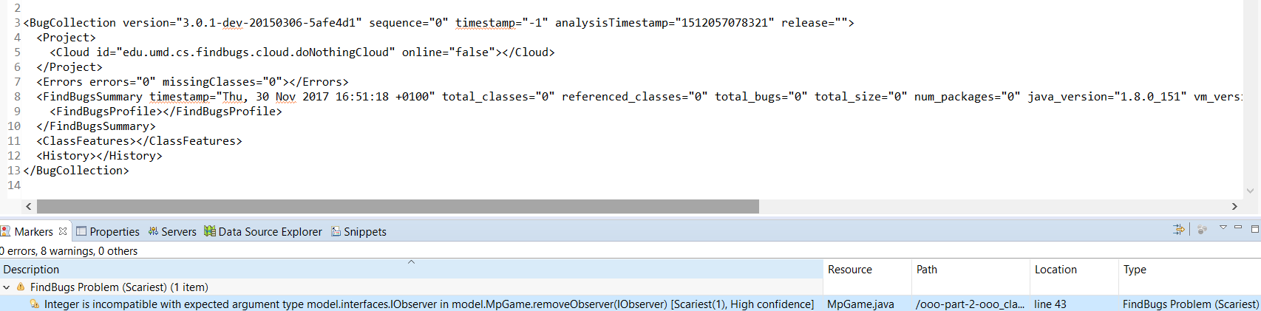

Explanation:

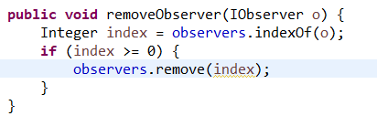

Integer is an unlikely argument in the remove() method since there are 2 different kinds of remove():

remove(Object) and remove(int), eclipse cannot differentiate between the two methods and give a warning message.